Plato on Truth, Falsehood and Deception
International Workshop 8th June 2026, University of Crete
Venue: Princeton Athens Center, 3 Timarchou Street, Athens and online
.
Programme
09:45–10:00 — Opening Remarks Eleni Kaklamanou
Chair: Pantelis Golitsis
10:00–10:45 — Thanasis Gkatzaras (Academy of Athens)
Truth and Falsehood in Republic V–VII
10:45–11:30 — Guus Eelink (University of Tübingen)
Infallibility in Plato’s Theory of Knowledge

11:30–11:45 — Coffee Break

Chair: Spyros Rangos
11:45–12:30 — Ermioni Prokopaki (Center for Hellenic Studies in Greece, Harvard University)
The Discussion of Falsehood in the Theaetetus: What Is It About and Why Does It Go Wrong?
12:30–13:15 — Lia Theodoroudi (University of Crete)
Plato’s Examination of Falsehood: Why the Sophist Succeeds Where the Theaetetus Fails

13:15–14:30 — Lunch Break

Chair: Panagiotis Thanassas
14:30–15:15 — Alexandra V. Alván León (University of Münster)
The Great Deceiver: Falsehood and Deception in Plato’s Sophist
15:15–16:00 — Xanthippe Bourloyanni (Academy of Athens)
Image, Predication, and Falsehood in the Sophist

16:00–16:15 — Coffee Break

Chair: Orestis Karatzoglou
16:15–17:00 — Giorgia Lugani (University of Cambridge)
Anatomy of Falsehood: Reframing Parmenides through Quotation and Allusion in Plato’s Dialogues
17:00–17:45 — Vilius Bartninkas (University of Vilnius)
Plato on Citizens, Dissent, and Moderation

17:45–18:00 — Short Break

Chair: Chloe Balla
18:00–18:45 — Emily Hulme (University of Sydney)
Evil Techne? Plato, Craft, and Value

18:45–19:00 — Closing Remarks

Organised by: Eleni Kaklamanou and Lia Theodoroudi (Department of Philosophy, University of Crete)
Funded by: University of Crete, Special Account for Research Funds (Research Project No. 11901)
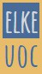
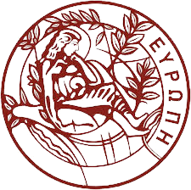

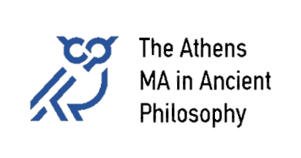
The programme
is listed in Athens time

